Project Documentation
Project Title: Electronic Card Transaction Analysis
- Project Overview
This project analyses electronic card transaction data using Excel and Power BI
To identify transaction trends and patterns.
- Tools Used
- Microsoft Excel
- Microsoft Power BI
- Dataset
-Source: Electronic Card Transaction Dataset
-Data contains: Date, Year, Month, Date Value, Status, Series Reference, Group, Magnitude, Subject, Units

- Steps Followed
- Collected and imported the electronic card transaction dataset.
- Cleaned and formatted the data in Excel.
- Checked the date, year, month, status and transaction-value fields.
- Imported the dataset into Power BI.
- Created suitable charts and visualizations.
- Created a Total Data Value KPI card.
- Created visualizations for monthly, yearly and status-wise transaction values.
- Created a bar chard to compare transaction values by Series Reference.
- Designed an interactive dashboard for easy analysis.
- Key Insights
- The total data values is approximately 69.86 billion.
- Transaction values show significant variation across different months.
- Year-wise analysis shows noticeable changes in transaction values over time.
- Status F contributes the largest share of the total data value compared with the other statuses.
- Different Series References show different levels of transaction values.
- Screenshots
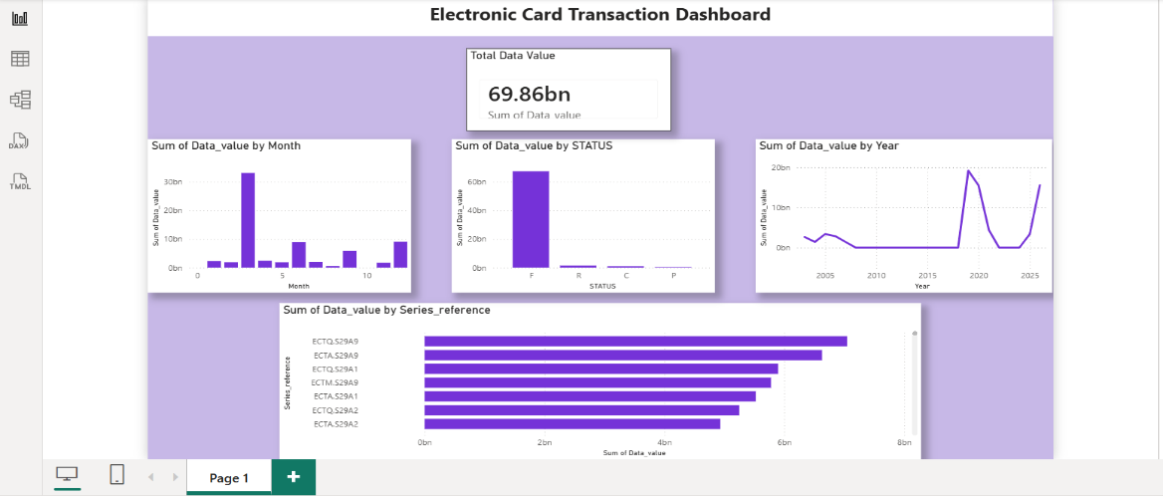

- Files Included
- https://drive.google.com/file/d/1oYE1WocvRoxk08ucYjO_60z-nULP9Hxe/view?usp=sharing – Dataset and data preparation
- https://drive.google.com/file/d/16diZf0adc-srctyCKnmAg0BbTXIZk2Dk/view?usp=sharing – Power BI dashboard
- README.md -Project documentation

- How to Use
- Open the Excel file to view the dataset.
- Open the .pbix file using Power BI Desktop.
- Explore the charts and KPI cards to analyze transaction values.
- Use the available filters/slicers, if included, to explore the data.

